DEBUGGING JAVA CODE IN ECLIPSE

Debugging is as important as writing a Java code. Programmers spent lot more time in debugging the code instead of writing the code.

Setting Breakpoints

The First step is to set a break point in our source code. This can be done by right-clicking in our application along the small left margin in our source code editor and select Toggle Break point. Alternatively, we can double-click on this position and generate the break point

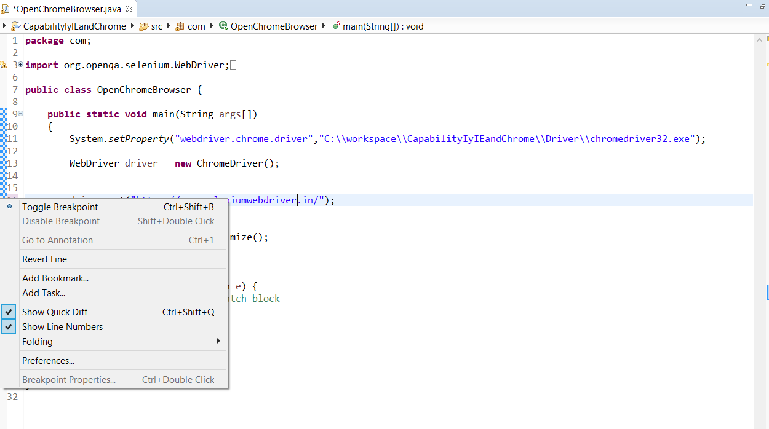
Starting the Debugger

To debug application, select a Java file which can be executed, right-click on it and select Debug As → Java Application.
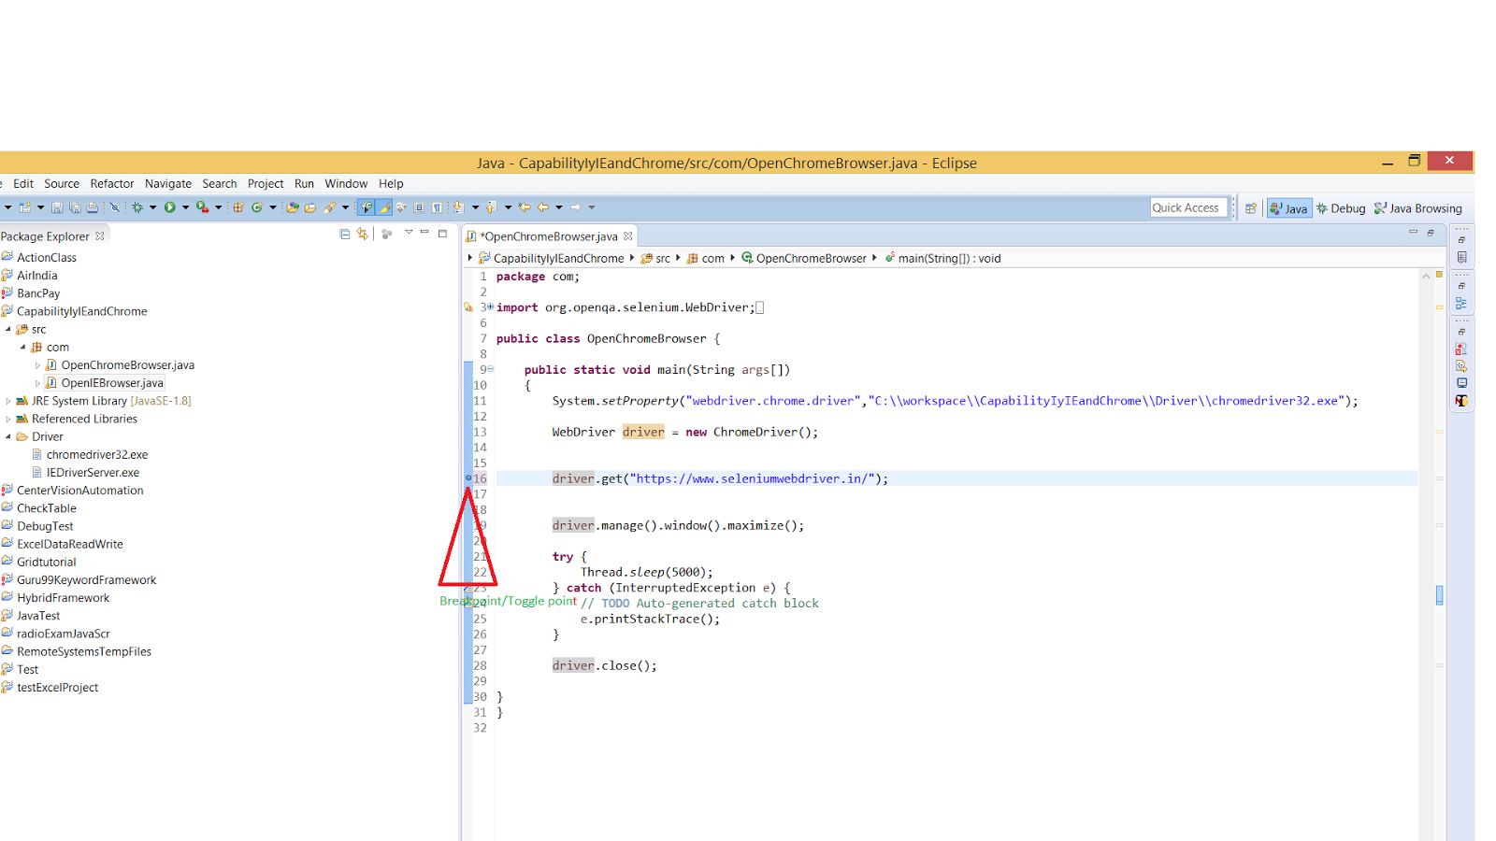

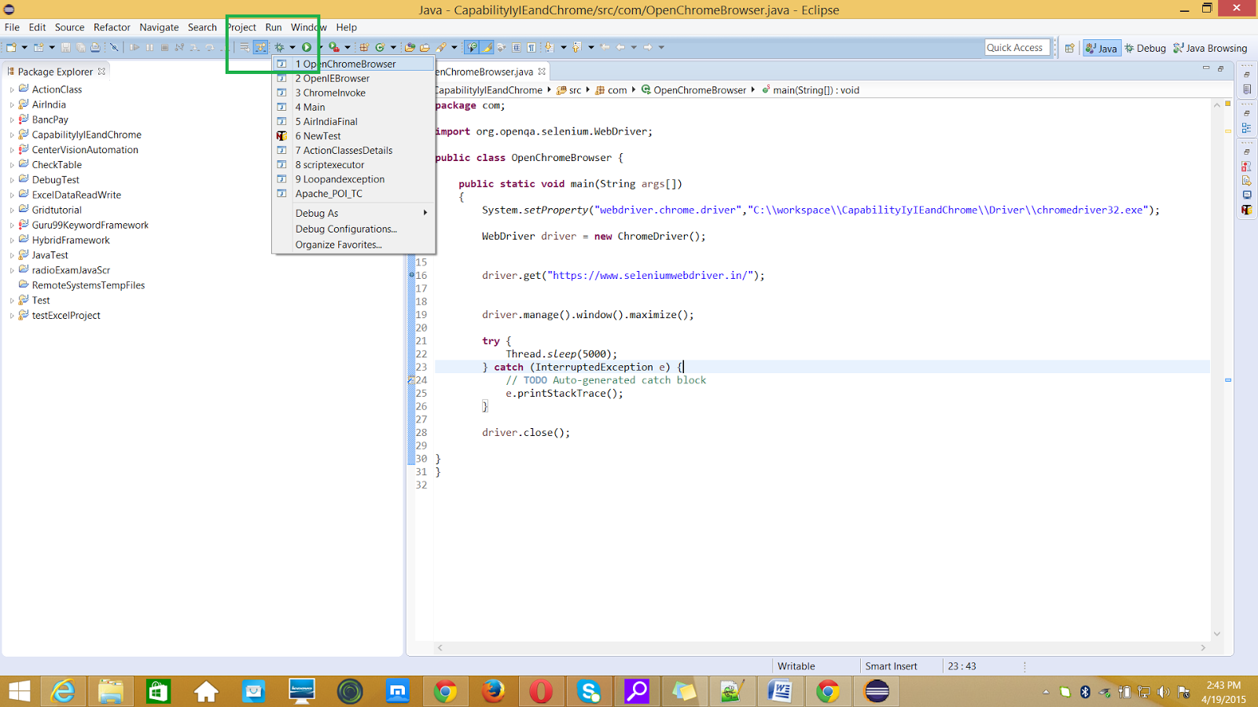
After we have started the application via the context menu, we can use the created launch configuration again via the Debug button in the Eclipse toolbar.
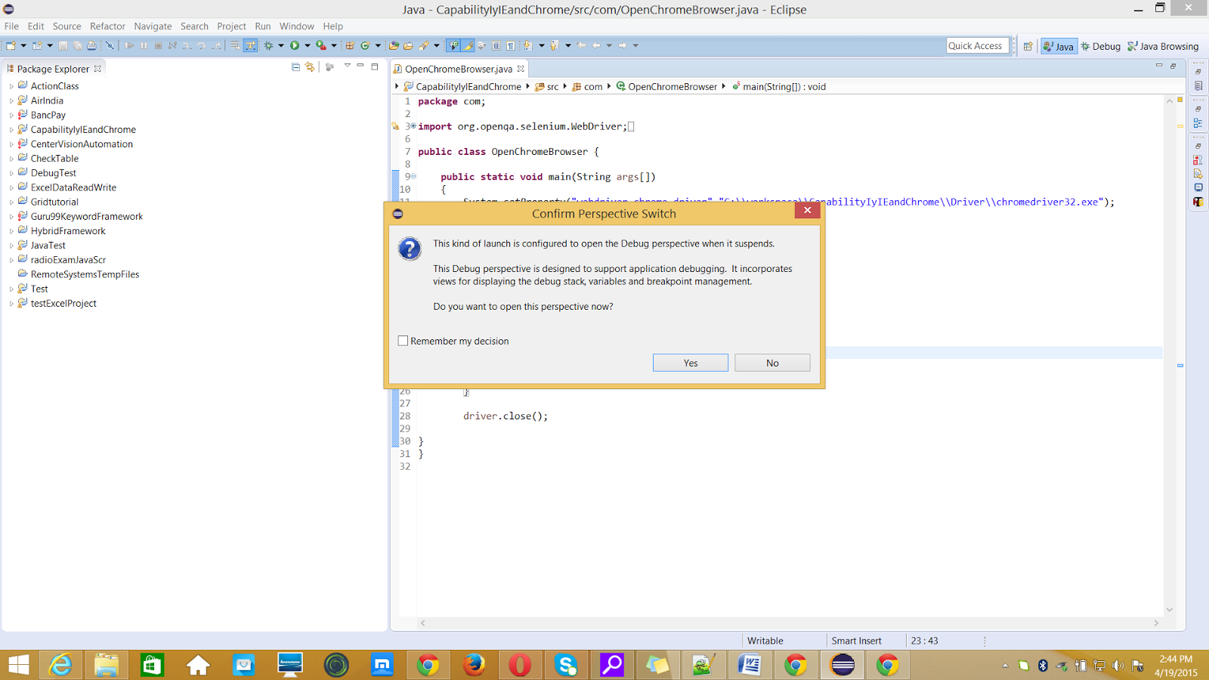

Breakpoints are shown on the marker bar. They are also visible in the Breakpoints View.

When the execution of code reaches a break point, the JVM suspends the execution of the program. At this point, we can inspect the memory and execute the program in a controlled manner.

When the execution of a program is paused, the debug view can be used to inspect the call stack.

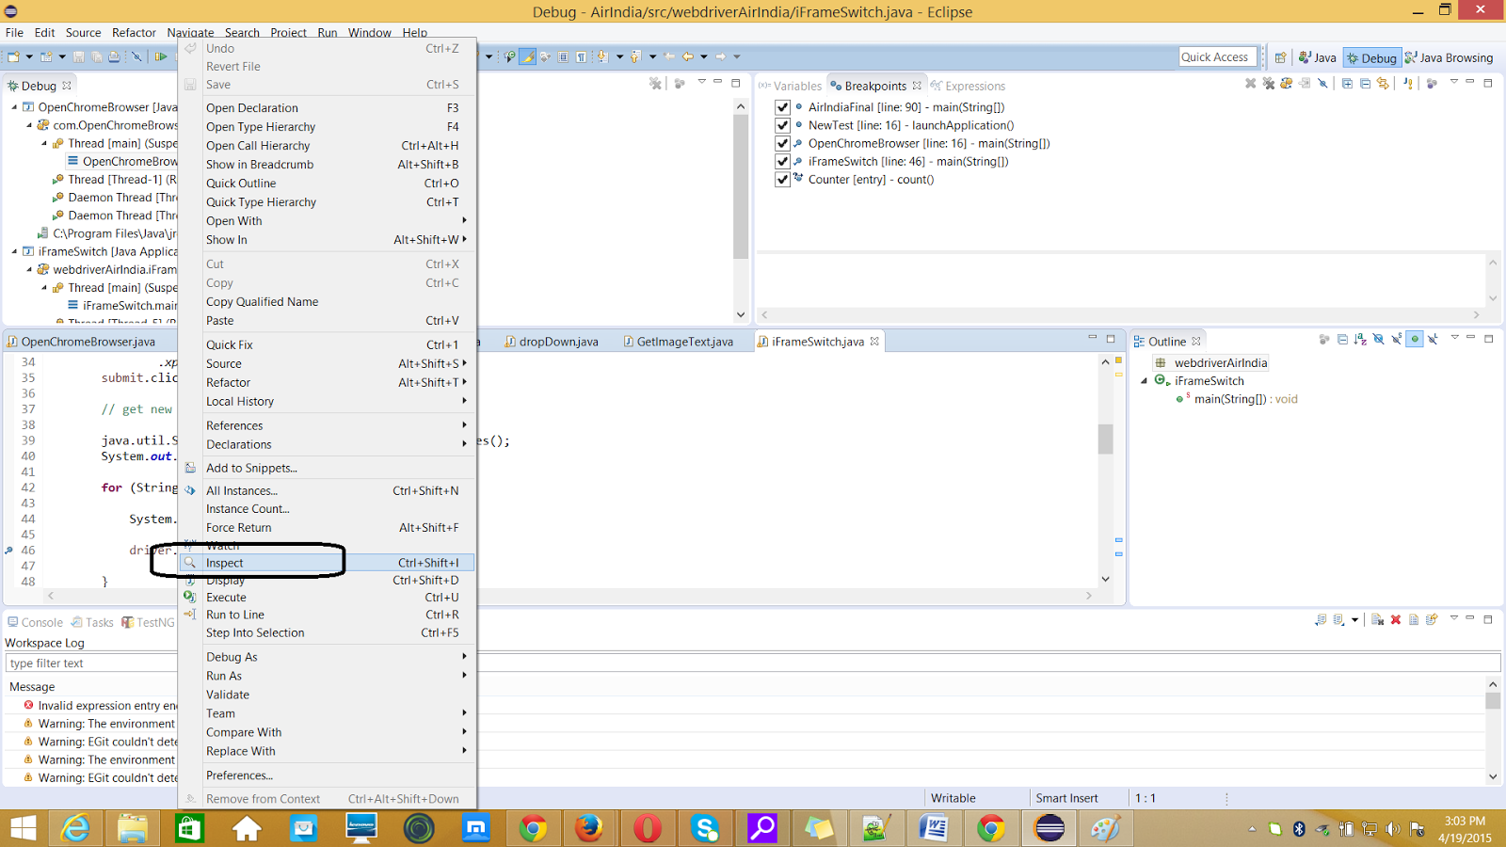

To view expression ,Breakpoints and Variables
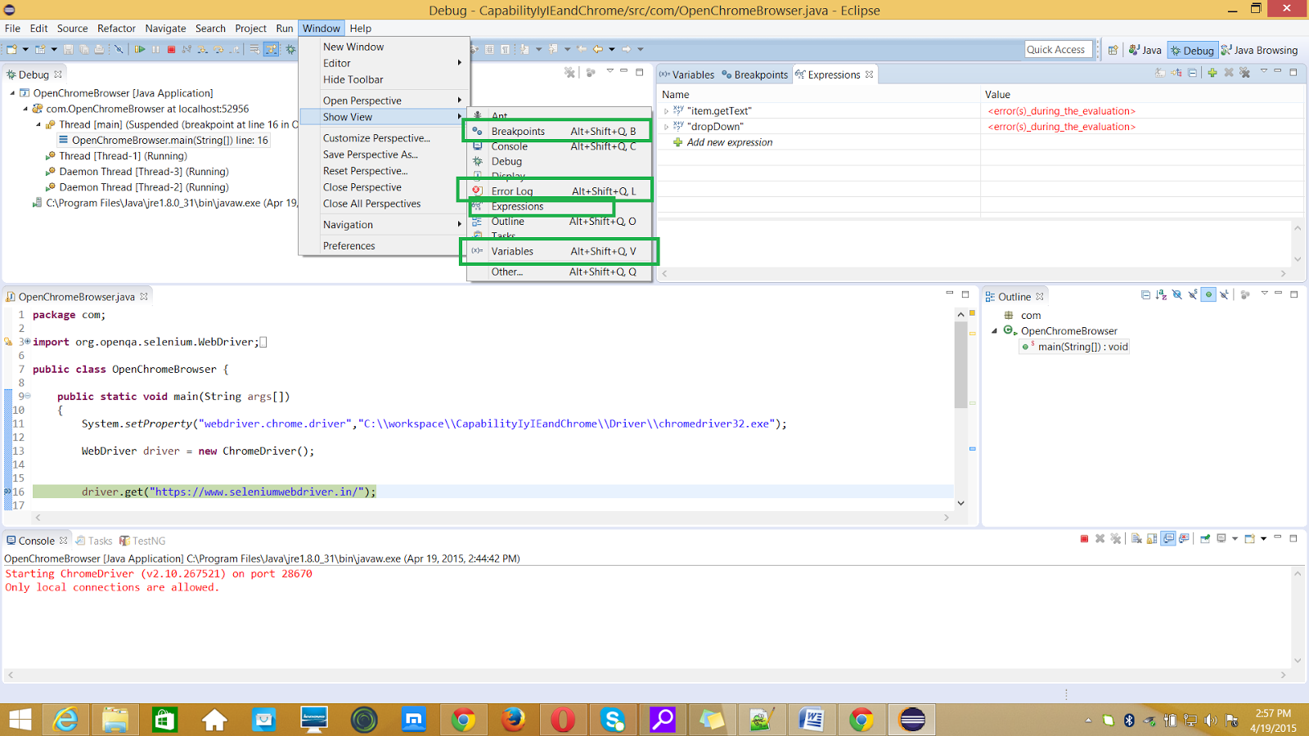

Controlling the program execution
Eclipse provides buttons in the toolbar for controlling the execution of the program you are debugging. Typically it is easier to use the corresponding keys to control this execution.

We can use the F5, F6, F7 and F8 key to step through our coding.

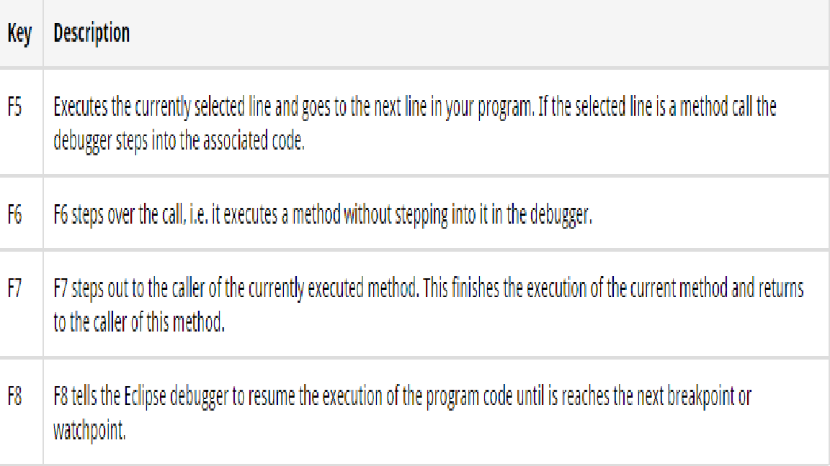

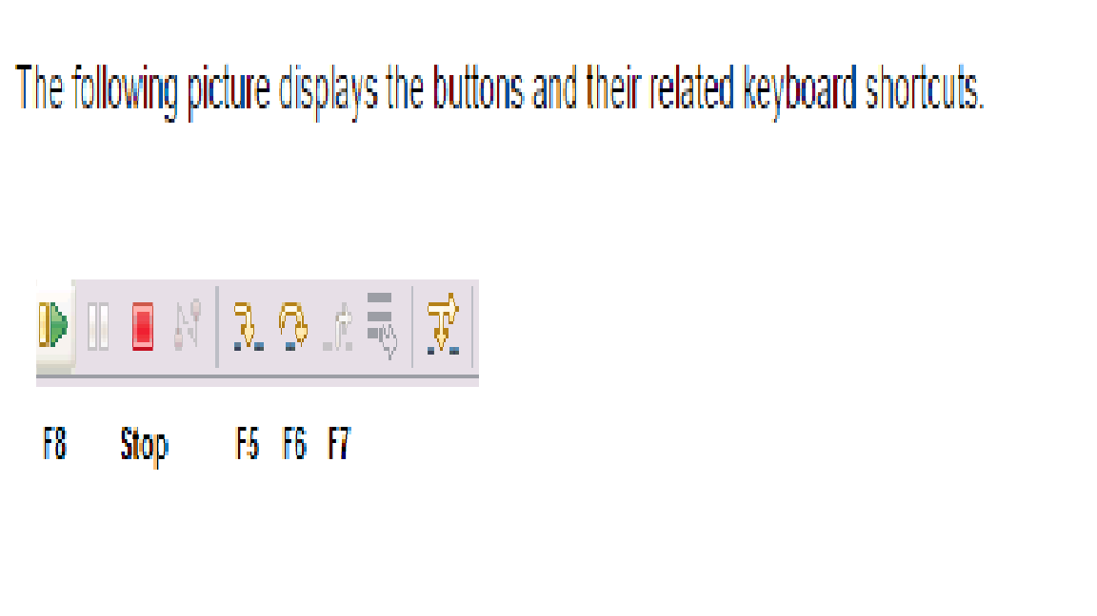
Breakpoints view and deactivating breakpoints

The Breakpoints view allows to delete and deactivate stop points, i.e. breakpoints and watchpoints and to modify their properties.

To deactivate a breakpoint, remove the corresponding checkbox in the Breakpoints view . To delete it you can use the corresponding buttons in the view toolbar. These options are depicted in the following screenshot

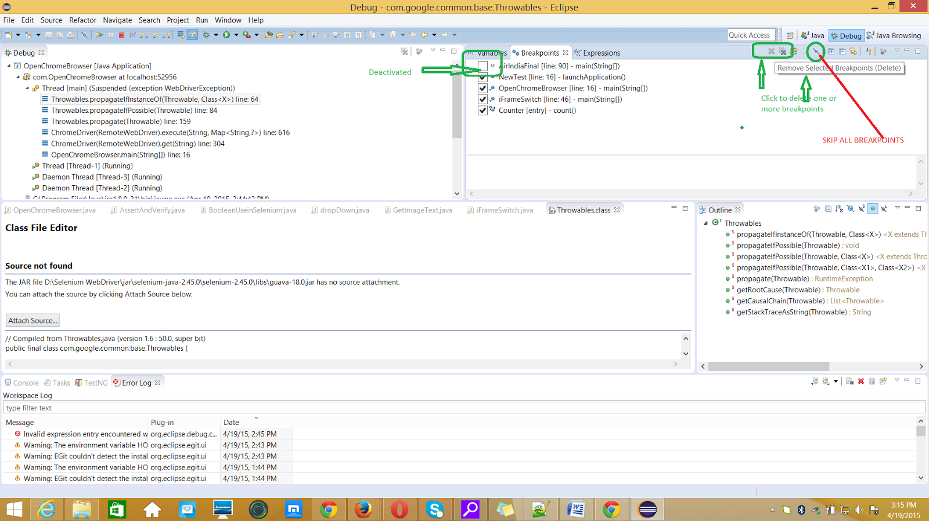

Evaluating variables in the debugger

The Variables view displays fields and local variables from the current executing stack. Please note this can only be viewed when we run the debugger.
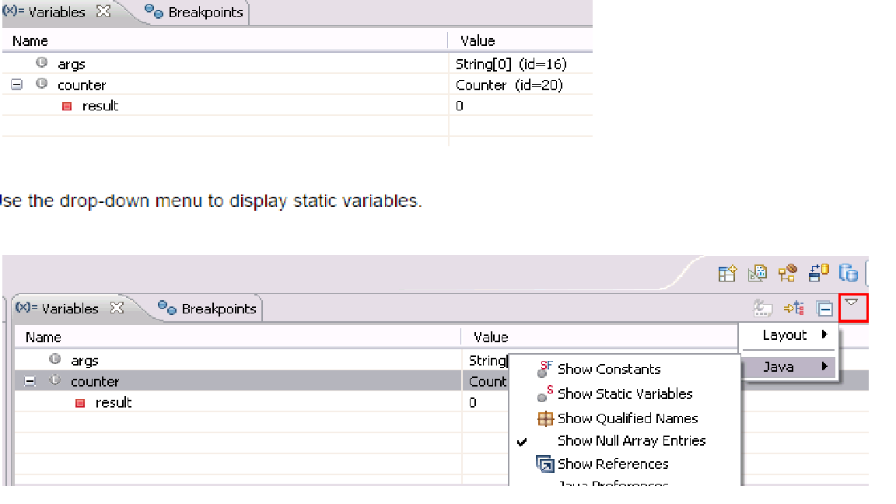

How to exit eclipse debug perspective?
Click on "java"-perspective tab at the right top side (i.e, between Quick Access & Debug texts)

